**EXPERIMENT : 11**

Create Table Bank(Bankid Number(5) Primary Key , Bankname Varchar(30),Headoffice Varchar(20),Branch Varchar(20) , Branchcode Number(5));



Insert Into Bank Values(1,'Canara Bank','Delhi','Manarcadu',10);

Insert Into Bank Values(2,'Axis Bank','Mumbai','Ayarkunam',25);

Insert Into Bank Values(3,'State Bank Of India','Kolkata','Kottayam',50);

select * from Bank;

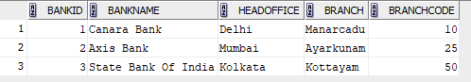

**GRANT**

Grant Select On Bank To C22csa59;



Select * From C22csa59.Bank;

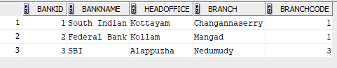

**REVOKE**

Revoke Select On Bank From C22csa59;



Select * From C22csa59.Bank;

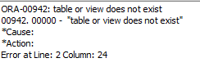

**GRANT**

GRANT SELECT,UPDATE ON Bank TO c22csa59;



UPDATE c22csa21.Bank SET BRANCH = ‘Kottayam’ WHERE bankname = ‘Punjab National Bank’;

Commit;